NUMBER PLATE DETECTION WITHOUT HELMET
Project submitted in partial fulfillment of the requirements for the award of the degree of

BACHELOR OF TECHNOLOGY

IN
COMPUTER SCIENCE AND ENGINEERING

BY
BADAVATH ANJALI (20C91A0507)

MYAKA MALVIKA (20C91A0534)
PARAKALA KAVITHA (20C91A0539)

Under the Esteemed guidance of

Mrs.CH.VIJAYA JYOTHI
Assistant Professor

DEPARTMENT OF COMPUTER SCIENCE AND ENGINEERING



HOLY MARY INSTITUTE OF TECHNOLOGY & SCIENCE
(COLLEGE OF ENGINEERING)

(Approved by AICTE New Delhi, Permanently Affiliated to JNTU Hyderabad, Accredited by NAAC with ‘A’ Grade)
Bogaram (V), Keesara (M), Medchal District - 501 301.

2023 - 2024

HOLY MARY INSTITUTE OF TECHNOLOGY & SCIENCE
(COLLEGE OF ENGINEERING)
(Approved by AICTE New Delhi, Permanently Affiliated to JNTU Hyderabad, Accredited by NAAC with ‘A’ Grade)
Bogaram (V), Keesara (M), Medchal Dist-501301.

DEPARTMENT OF COMPUTER SCIENCE AND ENGINEERING


CERTIFICATE

This is to certify that the mini project entitled “NUMBER PLATE DETECTION WITHOUT HELMET ” is being submitted by B. ANJALI(20C91A0507), M. MALVIKA (20C91A0534), P. KAVITHA (20C91A0539) in Partial fulfillment of the academic requirements for the award of the degree of Bachelor of Technology in “COMPUTER SCIENCE AND ENGINEERING” from HOLY MARY INSTITUTE OFTECHNOLOGY
& SCIENCE, JNTU Hyderabad during the year 2023- 2024.

INTERNAL GUIDE

MRS.CH. VIJAYA JYOTHI
Assistant Professor
Dept. of Computer Science & Engineering

HEAD OF THE DEPARTMENT

Dr .B.NARSIMHA
Professor & HoD
Dept. of Computer Science & Engineering

EXTERNAL EXAMINER

ACKNOWLEDGEMENT

The satisfaction and euphoria that accompany the successful completion of any task would be incomplete without the mention of the people who made it possible, who’s constant guidance and encouragement crowns all effort with success.
We take this opportunity to express my profound gratitude and deep regards to our Guide Mrs. Ch. Vijaya Jyothi,, Assistant Professor, Dept. of Computer Science & Engineering, Holy Mary Institute of Technology & Science for his / her exemplary guidance, monitoring and constant encouragement throughout the project work.
Our special thanks to Dr. B. Narsimha, Head of the Department, Dept. of Computer Science & Engineering, Holy Mary Institute of Technology & Science who has given immense support throughout the course of the project.
We also thank Dr. P. Bhaskara Reddy, the honorable Director of my college Holy Mary Institute of Technology & Science for providing me the opportunity to carry out this work.
At the outset, we express my deep sense of gratitude to the beloved Chairman A. Siddartha Reddy of Holy Mary Institute of Technology & Science, for giving me the opportunity to complete my course of work
We are obliged to staff members of Holy Mary Institute of Technology & Science for the valuable information provided by them in their respective fields. We are grateful for their cooperation during the period of my assignment.
Last but not the least we thank our Parents, and Friends for their constant encouragement without which this assignment would not be possible.

BADAVATH ANJALI (20C91A0507)
MYAKA MALVIKA (20C91A0534)
PARAKALA KAVITHA (20C91A0539)

DECLARATION

This is to certify that the work reported in the present project titled “NUMBER PLATE DETECTION WITHOUT HELMET” is a record of work done by us in the Department of Computer Science & Engineering, Holy Mary Institute of Technology and Science.
To the best of our knowledge no part of the thesis is copied from books/journals/internet and wherever the portion is taken, the same has been duly referred to in the text . The reports are based on the project work done entirely by us not copied from any other source.

BADAVATH ANJALI (20C91A0507)
MYAKA MALVIKA (20C91A0534)
PARAKALA KAVITHA (20C91A0539)

CONTENTS

ABSTRACT
Name of the Chapter | Page No.
1. INTRODUCTION 9
2.LITERATURE SURVEY 10
3. ANALYSIS 11-12
3.1. Existing System
3.2 Proposed System
3.3 System Requirements
3.3.1 Hardware Requirements
3.3.2 Software Requirements
4. SYSTEM DESIGN 13 -21
4.1 UML Description
4.2 UML Diagrams
5. IMPLEMENTATION AND RESULTS 22-42
5.1 Modules
5.2 Sample Code
5.3 Algorithms Used
5.4 System Study
5.5 Software Environment
5.6 Packages
6. SYSTEM TESTING 43 -45
7.RESULT & SCREENSHOTS 46 -47
8.CONCLUSION 48-49
8.1 Future Scope
9. BIBLIOGRAPHY 50

LIST OF IMAGES II
FIGURE PAGE NO
1.Use Case Diagram 16
2.Class Diagram 16
3.Collabaration Diagram 17
4.Sequence Diagram 18
5.Component Diagram 20
6.Activity Diagram 21
7.Deployment Diagram 22
8.Output 1 47
9.Output 2 47
10.Output 3 48
11. Final Output 48

LIST OF ABBREVIATIONS III

CCTV- Closed Circuit Television
OCR-Optical Character Recognition
API- Application Program Interface
YOLO-You Only Look Once
UML-Unified Modeling Language

ABSTRACT

The most prevalent method for ensuring that motorcyclists wear helmet is traffic police manually monitoring motorcyclists at road junctions or through CCTV footage and penalizing those without helmet. But it requires human intervention and efforts.
This paper proposes an automated system for detecting motorcyclists not wearing helmet and retrieving their motorcycle number plates from CCTV footage. The classification of motorcyclist from the given picture and then head portion is located and it is classified as helmet or non-helmet. Finally, for identified motorcyclist without helmet, number plate of motorcycle is detected and the characters on it are extracted.

1.INTRODUCTION

Helmet reduces the chances of skull getting decelerated, hence sets the motion of the head to almost zero. Cushion inside the helmet absorbs the impact of collision and as time passes head comes to a halt. It also spreads the impact to a larger area, thus safeguarding the head from severe injuries. More importantly it acts as a mechanical barrier between head and object to which the rider came into contact. Injuries can be minimized if a good quality full helmet is used. Traffic rules are there to bring a sense of discipline, so that the risk of deaths and injuries can be minimized significantly. However strict adherence to these laws is absent in reality. Hence efficient and feasible techniques have to be created to overcome these problems. Manual surveillance of traffic using CCTV is an existing methodology. But here so many iterations have to be performed to attain the objective and it demands a lot of human resource. Therefore, cites with millions of population having so many vehicles running on the roads cannot afford this inadequate manual method of helmet detection. So here we propose a methodology for full helmet detection and license plate extraction using YOLOv2, YOLOv3 and OCR. Basically helmet detection system involves following steps such as collection of dataset, moving object detection, background subtraction, object classification using neural networks

2.LITERATURE SURVEY
2.1 INTORDUCTION
This system aims in bringing the major safety measures while riding a two-wheeler both for the rider and the pillion. This has become a major cause of deaths in road accidents in many places where the vehicle density in very high and the people are least bothered to take care of themselves by taking proper precautionary measures while riding motorcycles. Though measures are taken by the government to avoid such problems by mandating the use of helmets for both the rider and the pillion, people are careless which is causing on the roads. So, keeping public safety as an important measure this mechanism of automated helmet detection plays a vital role where traffic police cannot be assigned for each and every street for implementing stricter rules. This project of automated helmet detection uses methods of machine learning to categorize vehicles as two wheelers or not and if it’s a two-wheeler then recognize the head part as the person wearing the helmet or not. If the rider or the pillion is not wearing the helmet then the image of the person with the vehicle is captured. Using different mechanisms, the number plate of the vehicle is recognized as the string of characters and numbers and stored in a database the details of the vehicle number plate and the captured images as the proof. Using this data fines can be imposed on the riders who repeated commit the mistake of not wearing the helmet .

3.ANALYSIS

3.1 EXISTING SYSTEM

Existing system monitors the traffic violations primarily through CCTV recordings, where the traffic police have to look into the frame where the traffic violation is happening, zoom into the license plate in case rider is not wearing helmet. But this requires lot of manpower and time as the traffic violations frequently and the number of people using motorcycles is increasing day-by-day. What if there is a system, which would automatically look for traffic violation of not wearing helmet while riding motorcycle/moped and if so, would automatically extract the vehicles’ license plate number. Recent research have successfully done this work based on CNN. But these works are limited with respect to efficiency, accuracy or the speed with which object detection and classification is done
3.1.1 DISADVANTAGES OF EXISTING SYSTEM
Limited accuracy in certain conditions.
3.2 PROPOSED SYSTEM
In this project we are detecting whether two wheeler rider wearing helmet or not, if he is not wearing helmet then we are extracting number plate of that two wheeler. To extract number plate we have YOLO CNN model with some train and test images and if you want to add some other images then send those images to us so we can include those images in YOLO model with annotation to extract number plate of those new images.
To implement above technique we are following or implemented below modules
- First image will be upload to the application and the using YOLOV2 we will check whether image contains person with motor bike or not, if YOLO model detect both person and motor bike then we will proceed to step 2.
- In this module we will use YOLOV3 model to detect whether object wear helmet or not, if he wear helmet then application will stop hear itself. If rider not wear helmet then application proceed to step 3.
- In this module we will extract number plate data using python tesseract OCR API. OCR will take input image and then extract vehicle number from it.
3.1.2 ADAVTAGES OF PROPOSED SYSTEM
Accuracy is high.
Faster traffic management.

3.3 SYSTEM REQUIREMENTS

3.3.1 HARDWARE REQUIREMENTS

- System : Pentium IV 2.4 GHZ
- Hard Disk : 40 GB.
- Floppy Drive : 1.44 Mb.
- Monitor : 14’ Color Monitor.
- Mouse : Optical Mouse.
- Ram : 512 Mb.

3.3.2 SOFTWARE REQUIREMENTS

• Operating system : Windows 7 Ultimate.
• Coding Language : Python.
• Front-End : Python.
• Designing : Html, Css, Javascript.
• Data Base : My SQL.

4.SYSTEM DESIGN

4.1 UML DESCRIPTION

UML DESCRIPTION UML stands for Unified Modeling Language. UML is a standardized general purpose modeling language in the field of object-oriented software engineering. The standard is managed, and was created by, the Object Management Group.

The goal is for UML to become a common language for creating models of object oriented computer software. In its current form UML is comprised of two major components: a Meta-model and a notation. In the future, some form of method or process may also be added to; or associated with, UML.

The Unified Modeling Language is a standard language for specifying, Visualization, Constructing and documenting the artifacts of software system, as well as for business modeling and other non-software systems.
The UML represents a collection of best engineering practices that have proven successful in the modeling of large and complex systems.

The UML is a very important part of developing objects oriented software and the software development process. The UML uses mostly graphical notations to express the design of software projects.

GOALS:

The Primary goals in the design of the UML are as follows:
1. Provide users a ready-to-use, expressive visual modeling Language so that they can develop and exchange meaningful models.
2. Provide extendibility and specialization mechanisms to extend the core concepts.
3. Be independent of particular programming languages and development process.
4. Provide a formal basis for understanding the modeling language.
5. Encourage the growth of OO tools market.
6. Support higher level development concepts such as collaborations, frameworks, patterns and component.

4.2 UML DIAGRAMS

USE CASE DIAGRAM

A use case diagram in the Unified Modeling Language (UML) is a type of behavioral diagram defined by and created from a Use-case analysis. Its purpose is to present a graphical overview of the functionality provided by a system in terms of actors, their goals (represented as use cases), and any dependencies between those use cases. The main purpose of a use case diagram is to show what system functions are performed for which actor. Roles of the actors in the system can be depicted.

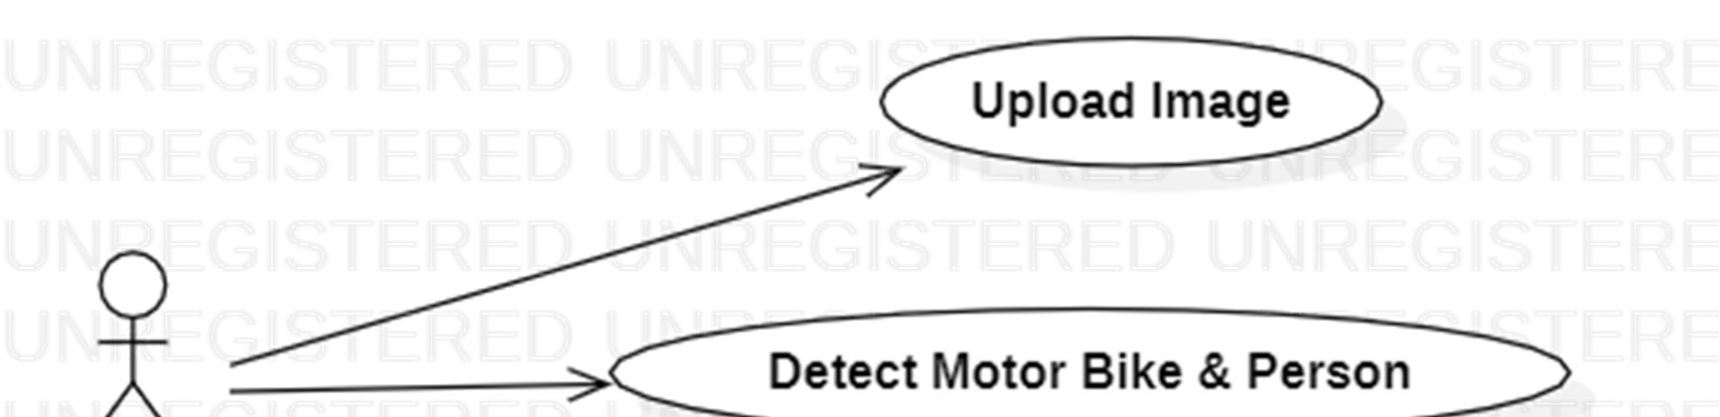
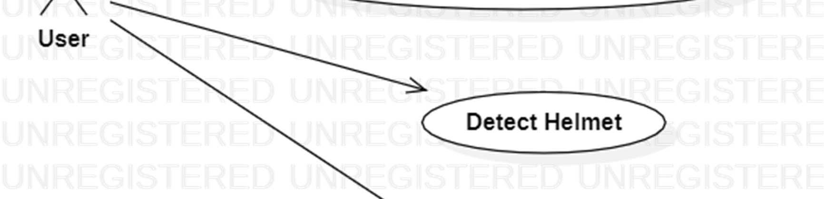


FIG 1: USE CASE DIAGRAM

CLASS DIAGRAM

In software engineering, a class diagram in the Unified Modeling Language (UML) is a type of static structure diagram that describes the structure of a system by showing the system's classes, their attributes, operations (or methods), and the relationships among the classes. It explains which class contains info FIG

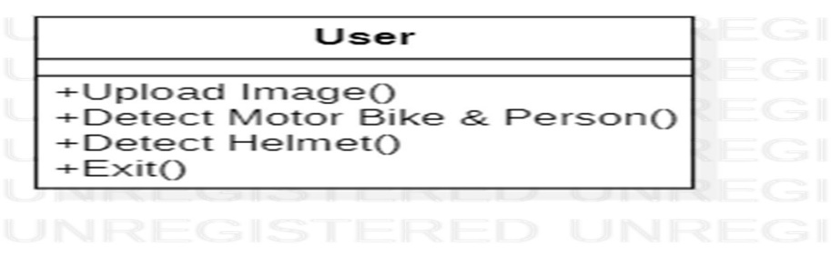

FIG 2: CLASS DIAGRAM

COLLABORATION

A collaboration diagram, also known as a communication diagram, is an illustration of the relationships and interactions among software objects in the Unified Modeling Language (UML). The diagrams can be used to portray the dynamic behavior of a particular usecase and define the role of each object.

Applicati
on
User
1:
Upload Image
2:
Detect Person and Bike
3:
Detect Helmet
4:
Logout

FIG 3: COLLABORATION DIAGRAM

SEQUENCE DIAGRAM
A sequence diagram in Unified Modeling Language (UML) is a kind of interaction diagram that shows how processes operate with one another and in what order. It is a construct of a Message Sequence Chart. Sequence diagrams are sometimes called event diagrams event scenarios, and timing diagrams.
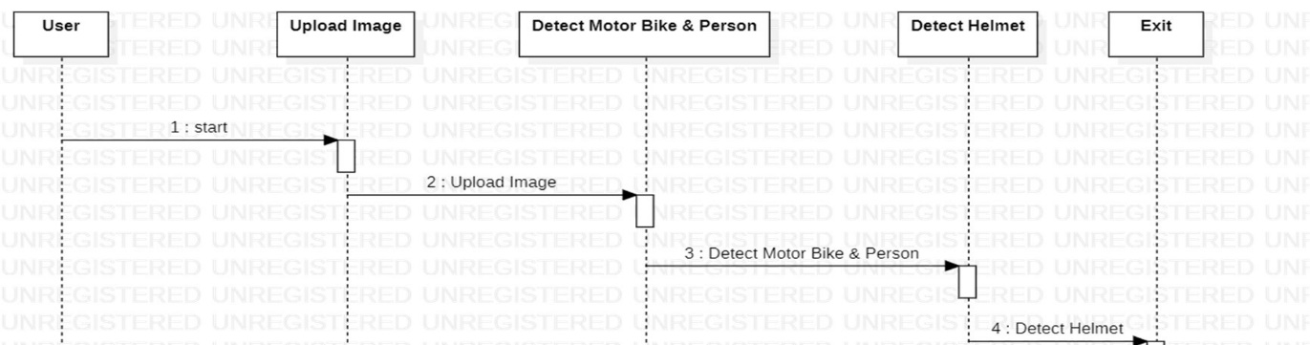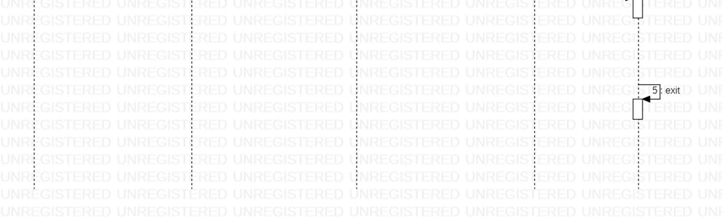

FIG 4: SEQUENCE DIAGRAM

Component Diagram

The UML component diagram shows how a software system will be composed of a set of deployable components – dynamic-link library (DLL) files , executable files, or web services-that interact through well- defined interfaces and which have their internal details hidden.
A component diagram is a type of UML (Unified Modeling Language) diagram that illustrates the components and their relationships in a system. In the context of number plate detection without helmet, a component diagram can help you visualize the high-level components of the system and how they interact. Here's a simplified example of the components you might have in a system for number plate detection without helmet:

1. Number Plate Detection System
- This could be the main component representing the entire system.
- Subcomponents may include:
- Image Capture Module: Responsible for capturing images, possibly from cameras or other sensors.
- Image Processing Module: Processes the captured images to identify and extract number plates.
- Number Plate Recognition Module: Analyzes the extracted information to recognize the alphanumeric characters on the number plate.

2. Helmet Detection System
- Although not explicitly required for number plate detection, you might have a separate component for helmet detection if this functionality is included in your system.
- Subcomponents may include:
- Helmet Detection Algorithm: Analyzes images to determine whether a helmet is present or not.

3. User Interface
- This component represents the user interface through which users interact with the system.
- Subcomponents may include:
- Display Module: Shows the processed images or results to users.
- User Input Module: Collects input from users if needed.

4. Database
- Stores relevant data, such as recognized number plates, timestamps, or other information.
- Subcomponents may include:
- Number Plate Database: Stores information about detected number plates.
- User Data (if applicable): Stores user-related data.

5. Communication Module
- Manages communication between different components of the system.
- Subcomponents may include:
- Interface with External Systems: If your system needs to interact with external databases, APIs, or services.

Remember that the actual components and their relationships will depend on the specific requirements and architecture of your system. This is just a generic example to illustrate how you might structure a component diagram for a number plate detection system without hComponent Diagram.

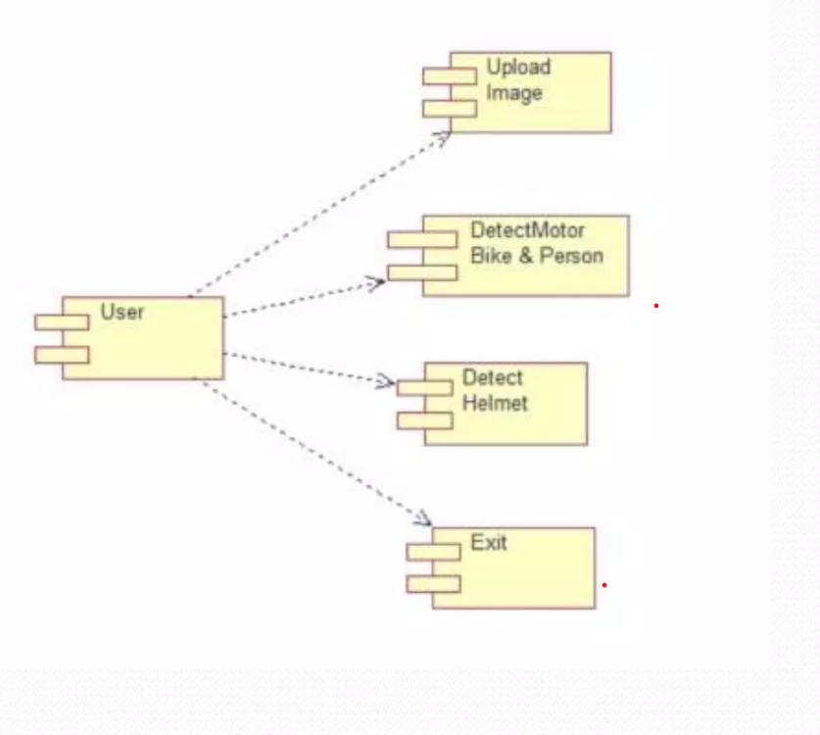
Fig 5: Component Diagram

Activity Diagram

An activity diagram is a type of UML diagram that shows the flow of activities in a system or a process. In the context of number plate detection without helmet, the activity diagram can illustrate the various steps involved in the process. Below is a simplified activity diagram along with a description of each activity
An activity diagram is a type of UML diagram that shows the flow of activities in a system or a process. In the context of number plate detection without helmet, the activity diagram can illustrate the various steps involved in the process. Below is a simplified activity diagram along with a description of each activity:

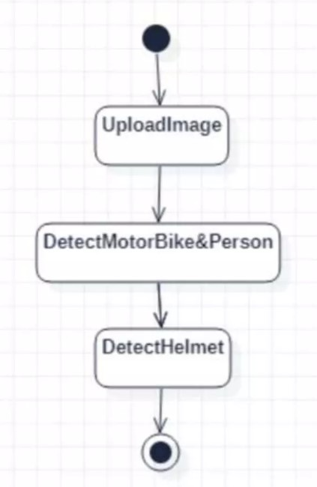

Fig 6: Activity diagram

Deployment diagram
In UML deployment diagrams model the physical architecture of a system. deployment diagrams shows the relationships between the software and hardware components in the system and the physical distribution of the processing.

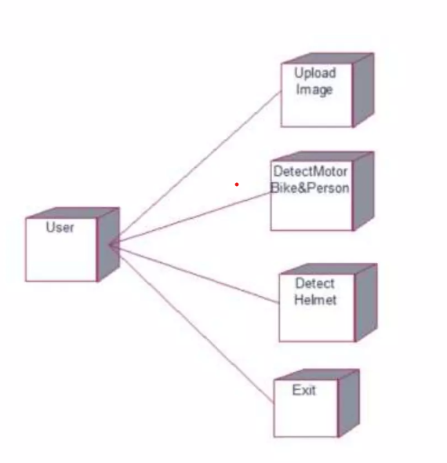
Fig 7: Deployment diagram

5. IMPLEMENTATION

5.1 MODULES

1.Upload Image
2.Detect Motor Bike & Person
The frame chosen is given as input to YOLOv2 object detection model, where the classes to be detected are „Motorbike‟, „Person‟. At the output, image with required class detection along with confidence of detection through bounding box and probability value is obtained.
With the help of functions given by Image AI library, only the detected objects are extracted and stored as separate images and named with class name and image number in order. For example, it will be saved as motorcycle-1, motorcycle-2, etc.… if extracted object is motorcycle or person-1, person-2, etc.… if extracted image is of person. The details of these extracted images which is stored in a dictionary which can be later used for further processing.
3.Detect Helmet
Once the person-motorcycle pair is obtained, the person images is given as input to helmet detection model. While testing the helmet detection model, some false detections were observed. So, the person image was cropped to get only top one-fourth portion of image.This ensures that false detection cases are eliminated as well as avoid cases leading to wrong results when the rider is holding helmet in hand while riding or keeping it on motorcycle while riding instead of wearing.
4.Exit

5.2 SAMPLE CODE

from tkinter import *
import tkinter
from tkinter import filedialog
import numpy as np
from tkinter.filedialog import askopenfilename
import pandas as pd
from tkinter import simpledialog
import numpy as np
import cv2 as cv
import subprocess
import time
import os
from yoloDetection import detectObject, displayImage
import sys
from time import sleep
from tkinter import messagebox
import pytesseract as tess
from keras.models import model_from_json
from keras.utils.np_utils import to_categorical

main = tkinter.Tk()
main.title("Helmet Detection")#designing main screen
main.geometry("800x700")
global filename
global loaded_model
global class_labels
global cnn_model
global cnn_layer_names
frame_count = 0
frame_count_out=0
confThreshold = 0.5
nmsThreshold = 0.4
inpWidth = 416
inpHeight = 416
global option
labels_value = []
with open("Models/labels.txt", "r") as file: #reading MRC dictionary
for line in file:
line = line.strip('\n')
line = line.strip()
labels_value.append(line)
file.close()
with open('Models/model.json', "r") as json_file:
loaded_model_json = json_file.read()
plate_detecter = model_from_json(loaded_model_json) plate_detecter.load_weights("Models/model_weights.h5")
plate_detecter._make_predict_function()

classesFile = "Models/obj.names";
classes = None

with open(classesFile, 'rt') as f:
classes = f.read().rstrip('\n').split('\n')

modelConfiguration = "Models/yolov3-obj.cfg";
modelWeights = "Models/yolov3-obj_2400.weights";
net = cv.dnn.readNetFromDarknet(modelConfiguration, modelWeights) net.setPreferableBackend(cv.dnn.DNN_BACKEND_OPENCV) net.setPreferableTarget(cv.dnn.DNN_TARGET_CPU)

def getOutputsNames(net):
layersNames = net.getLayerNames()
return [layersNames[i[0] - 1] for i in net.getUnconnectedOutLayers()]

def loadLibraries(): #function to load yolov3 model weight and class labels
global class_labels
global cnn_model
global cnn_la layer_names
class_labels = open('yolov3model/yolov3-labels').read().strip().split('\n')
#reading labels from yolov3 model
print(str(class_labels)+" == "+str(len(class_labels)))
cnn_model = cv.dnn.readNetFromDarknet('yolov3model/yolov3.cfg',
'yolov3model/yolov3.weights') #reading model
cnn_layer_names = cnn_model.getLayerNames() #getting layers from cnn model cnn_layer_names = [cnn_layer_names[i[0] - 1] for i in
cnn_model.getUnconnectedOutLayers()] #assigning all layers
def upload(): #function to upload tweeter profile
global filename
filename = filedialog.askopenfilename(initialdir="bikes")
#messagebox.showinfo("File Information", "image file loaded")
def detectBike():
global option
option = 0
indexno = 0
label_colors = (0,255,0)
try:
image = cv.imread(filename)
image_height, image_width = image.shape[:2]
except:
raise 'Invalid image path'
finally:
image, ops = detectObject(cnn_model, cnn_layer_names, image_height,
image_width, image, label_colors, class_labels,indexno)
if ops == 1:
displayImage(image,0)#display image with detected objects label
option = 1
else:
displayImage(image,0)
def drawPred(classId, conf, left, top, right, bottom,frame,option):
global frame_count
#cv.rectangle(frame, (left, top), (right, bottom), (255, 178, 50), 3)
label = '%.2f' % conf
if classes:
assert(classId < len(classes))
label = '%s:%s' % (classes[classId], label)
labelSize, baseLine = cv.getTextSize(label, cv.FONT_HERSHEY_SIMPLEX, 0.5,
1)
top = max(top, labelSize[1])
label_name,label_conf = label.split(':')
print(label_name+" === "+str(conf)+"== "+str(option))
if label_name == 'Helmet' and conf > 0.50:
if option == 0 and conf > 0.90:
cv.rectangle(frame, (left, top - round(1.5*labelSize[1])), (left +
round(1.5*labelSize[0]), top + baseLine), (255, 255, 255), cv.FILLED)
cv.putText(frame, label, (left, top), cv.FONT_HERSHEY_SIMPLEX, 0.75,
(0,0,0), 1)
frame_count+=1
if option == 0 and conf < 0.90:
cv.putText(frame, "Helmet Not detected", (10, top),
cv.FONT_HERSHEY_SIMPLEX, 0.75, (0,255,0), 2)

frame_count+=1
img = cv.imread(filename)
img = cv.resize(img, (64,64))
im2arr = np.array(img)
im2arr = im2arr.reshape(1,64,64,3)
X = np.asarray(im2arr)
X = X.astype('float32')
X = X/255
preds = plate_detecter.predict(X)
predict = np.argmax(preds)
#img = cv.imread(filename)
#img = cv.resize(img,(500,500))
#text = tess.image_to_string(img, lang='eng')
#text = text.replace("\n"," ")
#messagebox.showinfo("Number Plate Detection Result", "Number plate
detected as "+text)
textarea.insert(END,filename+"\n\n")
textarea.insert(END,"Number plate detected as "+str(labels_value[predict]))
if option == 1:
cv.rectangle(frame, (left, top - round(1.5*labelSize[1])), (left +
round(1.5*labelSize[0]), top + baseLine), (255, 255, 255), cv.FILLED)
cv.putText(frame, label, (left, top), cv.FONT_HERSHEY_SIMPLEX, 0.75,
(0,0,0), 1)
frame_count+=1

if(frame_count> 0):
return frame_count

def postprocess(frame, outs, option):
frameHeight = frame.shape[0]
frameWidth = frame.shape[1]
global frame_count_out
frame_count_out=0
classIds = []
confidences = []
boxes = []
cc = 0
for out in outs:
for detection in out:
scores = detection[5:]
classId = np.argmax(scores)
confidence = scores[classId]
if confidence > confThreshold:
center_x = int(detection[0] * frameWidth)
center_y = int(detection[1] * frameHeight)
width = int(detection[2] * frameWidth)
height = int(detection[3] * frameHeight)
left = int(center_x - width / 2)
top = int(center_y - height / 2)
classIds.append(classId)
#print(classIds)
confidences.append(float(confidence))
boxes.append([left, top, width, height])

indices = cv.dnn.NMSBoxes(boxes, confidences, confThreshold, nmsThreshold)
count_person=0 # for counting the classes in this loop.
for i in indices:
i = i[0]
box = boxes[i]
left = box[0]
top = box[1]
width = box[2]
height = box[3]
frame_count_out = drawPred(classIds[i], confidences[i], left, top, left + width,
top + height,frame,option)
my_class='Helmet'
unknown_class = classes[classId]
print("===="+str(unknown_class))
if my_class == unknown_class:
count_person += 1

print(str(frame_count_out))
if count_person == 0 and option == 1:
cv.putText(frame, "Helmet Not detected", (10, 50),
cv.FONT_HERSHEY_SIMPLEX, 0.75, (0,255,0), 2)
if count person >= 1 and option == 0:
#path = 'test_out/'
#cv.imwrite(str(path)+str(cc)+".jpg", frame) # writing to folder.
#cc = cc + 1
frame = cv.resize(frame,(500,500))
cv.imshow('img',frame)
cv.waitKey(50)
def detectHelmet():
textarea.delete('1.0', END)
if option == 1:
frame = cv.imread(filename)
frame_count =0
blob = cv.dnn.blobFromImage(frame, 1/255, (inpWidth, inpHeight), [0,0,0], 1,
crop=False)
net.setInput(blob)
outs = net.forward(getOutputsNames(net))
postprocess(frame, outs,0)
t, _ = net.getPerfProfile()
label = 'Inference time: %.2f ms' % (t * 1000.0 / cv.getTickFrequency())
print(label)
cv.putText(frame, label, (0, 15), cv.FONT_HERSHEY_SIMPLEX, 0.5, (0, 0,
255))
print(label)
else:
messagebox.showinfo("Person & Motor bike not detected in uploaded image",
"Person & Motor bike not detected in uploaded image")
def videoHelmetDetect():
global filename
videofile = askopenfilename(initialdir = "videos")
video = cv.VideoCapture(videofile)
while(True):
ret, frame = video.read()
if ret == True:
frame_count = 0
filename = "temp.png"
cv.imwrite("temp.png",frame)
blob = cv.dnn.blobFromImage(frame, 1/255, (inpWidth, inpHeight), [0,0,0], 1,
crop=False)
net.setInput(blob)
outs = net.forward(getOutputsNames(net))
postprocess(frame, outs,1)
t, _ = net.getPerfProfile()
#label=''
#cv.putText(frame, label, (0, 15), cv.FONT_HERSHEY_SIMPLEX, 0.5, (0, 0,
255))
cv.imshow("Predicted Result", frame)
if cv.waitKey(5) & 0xFF == ord('q'):
break
else:
break
video.release()
cv.destroyAllWindows()
def exit():
global main
main.destroy()
font = ('times', 16, 'bold')
title = Label(main, text='Number Plate Detection without Helmet', justify=LEFT)
title.config(bg='lavender blush', fg='DarkOrchid1')
title.config(font=font)
title.config(height=3, width=120)
title.place(x=100,y=5)
title.pack()
font1 = ('times', 14, 'bold')
model = Button(main, text="Upload Image", command=upload)
model.place(x=200,y=100)
model.config(font=font1)
uploadimage = Button(main, text="Detect Motor Bike & Person",
command=detectBike)
uploadimage.place(x=200,y=150)
uploadimage.config(font=font1)
classifyimage = Button(main, text="Detect Helmet", command=detectHelmet) classifyimage.place(x=200,y=200)
classifyimage.config(font=font1)

exitapp = Button(main, text="Exit", command=exit)
exitapp.place(x=200,y=250)
exitapp.config(font=font1)

font1 = ('times', 12, 'bold')
textarea=Text(main,height=15,width=60)
scroll=Scrollbar(textarea)
textarea.configure(yscrollcommand=scroll.set)
textarea.place(x=10,y=300)
textarea.config(font=font1)

loadLibraries()
main.config(bg='light coral')
main.mainloop()

History of YOLO
YOLO is the latest state-of-the-art real-time object detection algorithm. It is a single convolutional neural network that simultaneously predicts multiple bounding boxes and classes of the entire image in the single scan. The framework was developed by [16]. The network architecture was inspired by the GoogLeNet model for image classification [17]. The network has 24 convolutional layers followed by two fully connected layers. In YOLO, 1 × 1 reduction layers were used followed by 3 × 3 convolutional layers. The full network is shown in Fig. 1 [16].
Currently, there are three versions of YOLO (v1, v2 and v3). The original YOLO network is also termed as YOLOv1. In YOLO v2, it is an improved version of YOLO v1 which keeps the advantage on the speed with the introduction of batch normalization, anchor boxes and high-resolution classifier. In YOLO v3, a better feature extractor was introduced with the introduction of 53 convolutional layers trained on ImageNet. The accuracy of the YOLO v3 is better than YOLO v2 but it is slower than YOLO v2 due to more layers.

System overview
The flow chart that we have implemented in this paper is shown in Fig. 3. The YOLOv2 was used for real-time detection of LP for a non-helmeted motorcyclist. In the system, the video frame is taken as the input, and the expected output is the localized LP for a non-helmet motorcyclist. In our approach, the system checks the presence of a helmet on the motorcyclist. If the motorcyclist is without a helmet, the LP is extracted so that it can be given to ANPR technology for recognition of characters and fine the defaulters.

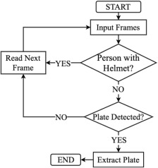
Fig 3: System Overview

This paper does the process of extracting the objects from the image using YOLO object detection and has 3 3segments in the entire process
1. Helmet detection - Annotated images are given to YOLOv3 model for training and the actual input for detection is given after training the model.
2. License plate Extraction – once the person without helmet is detected then the class with respect to person and corresponding vehicle and its number plate is detected and the number plate is cropped and saved.
3.License plate recognition – The extracted number plate detected previously is passed on to OCR (Optical Character Recognition), the module outputs the string of numbers and alphabets with the accuracy percentage of the string recognized. This paper does not deal with the ability to detect the difference between motorcycle and a no motorcycle and this project cannot be implemented for input as videos since the input given through OCR is images only.

Yolo V2 Algorithm
You Only Look Once (YOLO) is a popular object detection algorithm that has been widely used in computer vision applications. YOLO V2 is the second version of the YOLO algorithm, which was introduced in 2016. YOLO V2 is an improved version of the original YOLO algorithm, which is faster and more accurate than its predecessor. In this article, we will discuss the architecture of YOLO V2 and how it works.
The architecture of YOLO V2 consists of 24 convolutional layers and 2 fully connected layers. The input image is first passed through a series of convolutional layers, which extract features from the image. These features are then used to predict the bounding boxes and class probabilities of the objects in the image.
One of the key improvements in YOLO V2 is the use of anchor boxes. Anchor boxes are pre-defined boxes of different sizes and aspect ratios that are used to predict the bounding boxes of objects in the image. By using anchor boxes, YOLO V2 is able to predict more accurate bounding boxes for objects of different sizes and shapes.
Another improvement in YOLO V2 is the use of batch normalization. Batch normalization is a technique that normalizes the input to each layer, which helps to reduce overfitting and
improve the accuracy of the model.

5.3ALGORITMS USED

YOLO v2 ALGORITM
- It stands for You only look once and developed by Joseph Redmon
- You only look once (YOLO) is a state-of-the-art, real-time object detection system.
- It can processes images at 40-90 FPS.
- It contains three steps
- Residual blocking – grid view
- Bounding box regression – Recognizes all objects
- Intersection Over Union (IOU)- focus on required object

5.4 SYSTEM STUDY

FEASIBILITY STUDY

The feasibility of the project is analyzed in this phase and business proposal is put forth with a very general plan for the project and some cost estimates. During system analysis the feasibility study of the proposed system is to be carried out. This is to ensure that the proposed system is not a burden to the company. For feasibility analysis, some understanding of the major requirements for the system is essential.
Three key considerations involved in the feasibility analysis are,
- ECONOMICAL FEASIBILITY
- TECHNICAL FEASIBILITY
- SOCIAL FEASIBILITY
- ECONOMICALLY FEASIBILITY
This study is carried out to check the economic impact that the system will have on the organization. The amount of fund that the company can pour into the research and development of the system is limited. The expenditures must be justified. Thus the developed system as well within the budget and this was achieved because most of the technologies used are freely available. Only the customized products had to be purchased.

- TECHNICAL FEASIBILITY
This study is carried out to check the technical feasibility, that is, the technical requirements of the system. Any system developed must not have a high demand on the available technical resources. This will lead to high demands on the available technical resources. This will lead to high demands being placed on the client. The developed system must have a modest requirement, as only minimal or null changes are required for implementing this system.

- SOCIAL FEASIBILITY
The aspect of study is to check the level of acceptance of the system by the user. This includes the process of training the user to use the system efficiently. The user must not feel threatened by the system, instead must accept it as a necessiy. The level of acceptance by the users solely depends on the methods that are employed to educate the user about the system and to make him familiar with it. His level of confidence must be raised so that he is also able to make some constructive criticism, which is welcomed, as he is the final user of the system.

5.5 SOFTWARE ENVIRONMENT
5.5.1 PYTHON
Python is currently the most widely used multi-purpose, high-level programming language. Python allows programming in Object-Oriented and Procedural paradigms. Python programs generally are smaller than other programming languages like Java. Programmers have to type relatively less and indentation requirement of the language, makes them readable all the time. Python language is being used by almost all tech-giant companies like – Google, Amazon, Facebook, Instagram, Dropbox, Uber… etc.
The biggest strength of Python is huge collection of standard library which can be used for the following:
- Machine Learning
- GUI Applications (like Kivy, Tkinter, PyQt etc. )
- Web frameworks like Django (used by YouTube, Instagram, Dropbox)
- Image processing (like Opencv, Pillow)
- Web scraping (like Scrapy, BeautifulSoup, Selenium)
- Test frameworks
- Multimedia

5.5.2 Advantages of Python
- Extensive Libraries
- Extensible
- Embeddable
- Improved Productivity
- IOT Opportunities
- Simple and Easy
- Readable
- Object-Oriented
- Free and Open-Source
- Portable
11.Interpreted

5.5.3 Disadvantages of Python
- Speed Limitations
- Weak in Mobile Computing and Browsers
- Design Restrictions
- Underdeveloped Database Access Layers
- Simple

5.5.4 Machine Learning
Before we take a look at the details of various machine learning methods, let's start by looking at what machine learning is, and what it isn't. Machine learning is often categorized as a subfield of artificial intelligence, but I find that categorization can often be misleading at first brush. The study of machine

learning certainly arose from research in this context, but in the data science application of machine learning methods, it's more helpful to think of machine learning as a means of building models of data.
Fundamentally, machine learning involves building mathematical models to help understand data. "Learning" enters the fray when we give these models tunable parameters that can be adapted to observed data; in this way the program can be considered to be "learning" from the data. Once these models have been fit to previously seen data, they can be used to predict and understand aspects of newly observed data. I'll leave to the reader the more philosophical digression regarding the extent to which this type of mathematical, model-based "learning" is similar to the "learning" exhibited by the human brain. Understanding the problem setting in machine learning is essential by using these tools effectively.
Categories Of Machine Leaning
At the most fundamental level, machine learning can be categorized into two main types:
- supervised learning
- unsupervised learning.

- Supervised learning involves somehow modeling the relationship between measured features of data and some label associated with the data; once this model is determined, it can be used to apply labels to new, unknown data. This is further subdivided into classification tasks and regression tasks: in classification, the labels are discrete categories, while in regression, the labels are continuous quantities. We will see examples of both types of supervised learning in the following section.
- Unsupervised learning involves modeling the features of a dataset without reference to any label, and is often described as "letting the dataset speak for itself." These models include tasks such as clustering and dimensionality reduction. Clustering algorithms identify distinct groups of data, while dimensionality reduction algorithms search for more succinct representations of the data. We will see examples of both types of unsupervised learning in the following section.

Applications of Machine Learning
Machine Learning is the most rapidly growing technology and according to researchers we are in the golden year of AI and ML. It is used to solve many realworld complex problems which cannot be solved with traditional approach.
Following are some real-world applications of ML −
- Emotion analysis
- Sentiment analysis
- Error detection and prevention
- Weather forecasting and prediction
- Stock market analysis and forecasting
- Speech synthesis
- Speech recognition
- Customer segmentation
- Object recognition
- Fraud detection
- Fraud prevention
- Recommendation of products to customer in online shopping
5.5.5 Advantages of Machine learning
- Easily identifies trends and patterns
- No human intervention needed (automation)
- Continuous Improvement
- Handling multi-dimensional and multi-variety data
- Wide Applications

5.5.6 Disadvantages of Machine Learning

- Data Acquisition
- Time and Resources
- Interpretation of Results
- High error-susceptibility
5.6 PACKAGES
Tensorflow
TensorFlow is a free and open-source software library for dataflow and differentiable programming across a range of tasks. It is a symbolic math library, and is also used for machine learning applications such as neural networks. It is used for both research and production at Google.
TensorFlow was developed by the Google Brain team for internal Google use. It was released under the Apache 2.0 open-source license on November 9, 2015.

Numpy
Numpy is a general-purpose array-processing package. It provides a highperformance multidimensional array object, and tools for working with these arrays. It is the fundamental package for scientific computing with Python. It contains various features including these important ones:
- A powerful N-dimensional array object
- Sophisticated (broadcasting) functions
- Tools for integrating C/C++ and Fortran code
- Useful linear algebra, Fourier transform, and random number capabilities
Besides its obvious scientific uses, Numpy can also be used as an efficient multi-dimensional container of generic data. Arbitrary data-types can be defined using Numpy which allows Numpy to seamlessly and speedily integrate with a wide variety of databases.

Pandas
Pandas is an open-source Python Library providing high-performance data manipulation and analysis tool using its powerful data structures. Python was majorly used for data munging and preparation. It had very little contribution towards data analysis. Pandas solved this problem. Using Pandas, we can accomplish five typical steps in the processing and analysis of data, regardless of the origin of data load, prepare, manipulate, model, and analyze. Python with Pandas is used in a wide range of fields including academic and commercial domains including finance, economics, Statistics, analytics, etc.
Matplotlib
Matplotlib is a Python 2D plotting library which produces publication quality figures in a variety of hardcopy formats and interactive environments across platforms. Matplotlib can be used in Python scripts, the Python and IPython shells, the Jupyter Notebook, web application servers, and four graphical user interface toolkits. Matplotlib tries to make easy things easy and hard things possible. You can generate plots, histograms, power spectra, bar charts, error charts, scatter plots, etc., with just a few lines of code. For examples, see the sample plots and thumbnail gallery.
For simple plotting the pyplot module provides a MATLAB-like interface, particularly when combined with IPython. For the power user, you have full control of line styles, font properties, axes properties etc, via an object oriented interface or via a set of functions familiar to MATLAB users

Scikit – learn
Scikit-learn provides a range of supervised and unsupervised learning algorithms via a consistent interface in Python. It is licensed under a permissive simplified BSD license and is distributed under many Linux distributions, encouraging academic and commercial use.

Python
Python is an interpreted high-level programming language for generalpurpose programming. Created by Guido van Rossum and first released in 1991, Python has a design philosophy that emphasizes code readability, notably using significant whitespace.
Python features a dynamic type system and automatic memory management. It supports multiple programming paradigms, including object-oriented, imperative, functional and procedural, and has a large and comprehensive standard library.
- Python is Interpreted − Python is processed at runtime by the interpreter. You do not need to compile your program before executing it. This is similar to PERL and PHP.
- Python is Interactive − you can actually sit at a Python prompt and interact with the interpreter directly to write your programs.
- Python also acknowledges that speed of development is important. Readable and terse code is part of this, and so is access to powerful constructs that avoid tedious repetition of code. Maintainability also ties into this may be an all but useless metric, but it does say something about how much code you have to scan, read and/or understand to troubleshoot problems or tweak behaviors. This speed of development, the ease with which a programmer of other languages can pick up basic Python skills and the huge standard library is key to another area where Python excels. All its tools have been quick to implement, saved a lot of time, and several of them have later been patched and updated by people with no Python background - without bre

6. SYSTEM TESTING

Software testing is a critical element of software quality assurance and represents the ultimate reviews of specification, design and coding. Testing presents an interesting anomaly of the software. During earlier definition and development phases, it was attempted to build software from abstract concept to a tangible implementation.
The testing phase involves the testing of the developed system using various set data. Presentation of test data plays a vital role in system testing. After preparing the test data the system under study was tested using test data. While testing the system by using test data errors were found and corrected. A series of tests were performed for the proposed system before the system was ready for implementation.
The various types of testing done on the system are:

- Unit Testing
- Integration Testing
- User Acceptance Testing
- System Testing

Unit testing
Unit testing focuses verification effort on the smallest unit of software design, the module. It comprises the set of test performed by the programmer prior to integration of the unit into larger system. The testing was carried out during the coding stage itself. In this step each module is found to be working satisfactorily as regards to the expected output from the module.
Each form is treated as a unit and tested thoroughly for bugs. The following is a list of some of the test cases :
1) In the login form, if a member does not enter a value for userId and password, then the user is prompted with the error message “userId and password should not be blank”.
2) In the login form, if a member enters wrong values for userId and password, then the user is prompted with the error message “Invalid userId and password. Try again.”.
3) In book Entry screen and new student, teacher screen, all the fields should have a value. Otherwise, the user is prompted with an appropriate error messages.

4) In book transactions form, member id, book no, issue date, and return date are mandatory. If not provided, then the system will prompt the user with the error message “Fields should not be blank”.
Integration Testing
Integration testing is a systematic technique for constructing the program structure while at the same time conducting tests to uncover error associated within the interface. The objective is to take unit tested modules and build a program structure that has been dictated by design. All modules are combined in this step. The entire program is tested as whole. And chaos in interfaces may usually result. A set of errors is encountered in such a case.
The integration testing can be carried out using two methodologies:
# Top Down Integration
# Bottom Up Integration
The first one is done where integration is carried out by addition of major modules to minor modules. While Bottom Up integration follows combination of smaller ones to larger one. Here, Bottom-Up Integration is followed. Even though correction was difficult because the isolation of causes is complicated by the vastness of the entire program, all the errors found in the system were corrected and then forwarded to the next testing steps.
The navigation among all the screens have been thoroughly verified so that the user of the system can move from one form to another form.
The connectivity between the forms and the database has been checked. In case of any malfunctions, the user will be informed about the problem.
User Acceptance Testing
User acceptance of a system is the key factor for the success of any system. The system under consideration was tested for users acceptance by constantly keeping in touch with the perspective system user at the time of developing and making changes wherever required. This is done with the regards to the following points:
A system may be defined as a set of instructions combined in the same form and directed to some purpose. Before any development is undertaken certain specifications are prepared which objectively describe the application system. The System specifications are made after consulting the end user managers of the relevant departments. Software to be developed is planned on the basis of requirement of the user. The problem definition statement description of present situation and goal to be achieved by news system.

The success of system depends on how accurately a problem is defined, thoroughly investigated carried out through choice of solution. User need identification and analysis that are concerned with what the uses needs rather than what he/she wants.
System explains how to perform specific activities or task, which does what and what.
System Testing
Testing the behavior of the whole software/system as defined in software requirements specification(SRS) is known as system testing, its main focus is to verify that the customer requirements are fulfilled.
System testing is done after integration testing is complete. System testing should test functional and non functional requirements of the software. The test types followed in system testing differ from organization to organization.
The project is executed and tested on the machines that satisfy the given hardware and software requirements. It was executed successfully with the specified hardware and operating system.

7.RESULT SCREENSHOTS
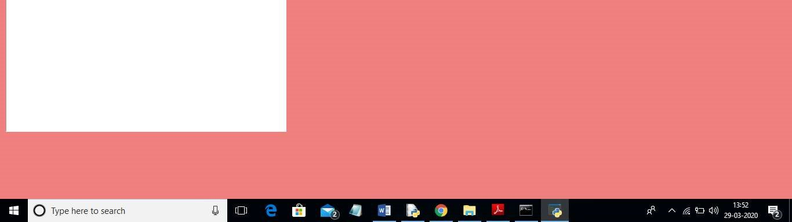
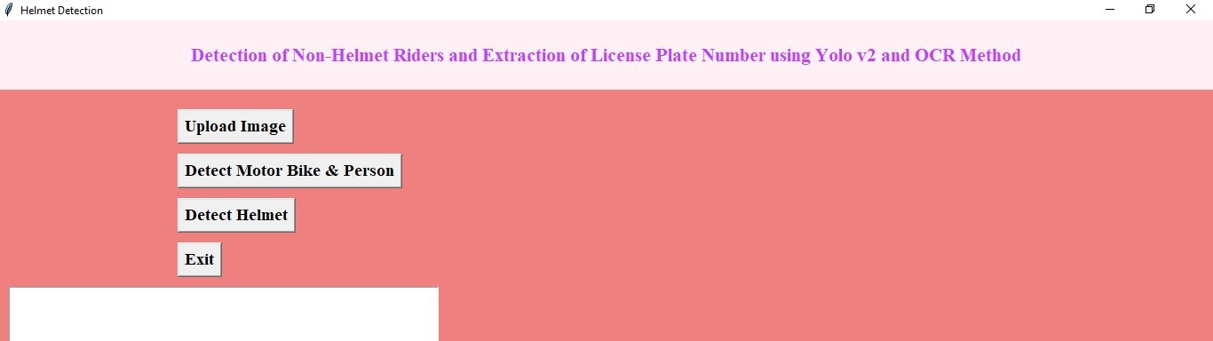


In above screen click on ‘Upload Image’ button and upload image

FIG 7.1: OUTPUT 1

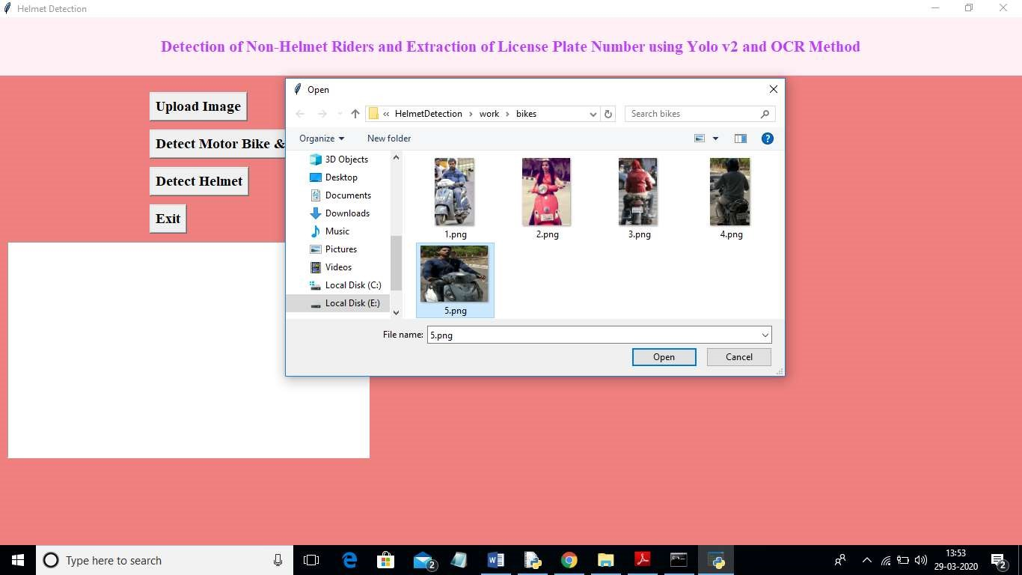
In above screen I selected one image as ‘5.png’ and click on ‘Open’ button to load image. Now click on ‘Detect Motor Bike & Person’ button to detect whether image contains person with motor bike or not
FIG 7.2: OUTPUT 2
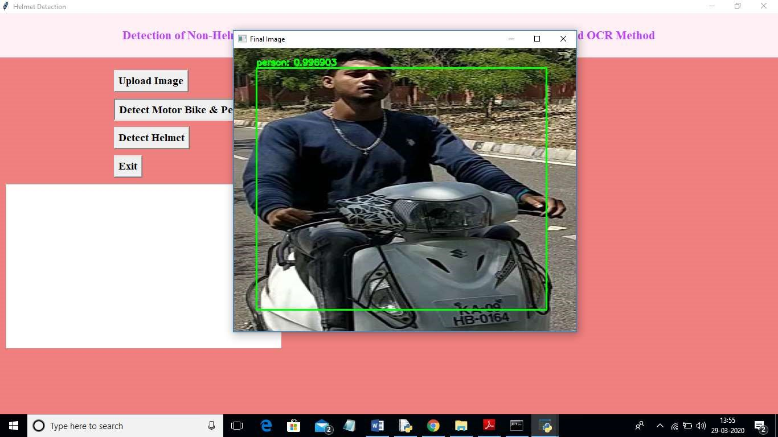
In above screen yolo detected image contains person and bike and now click on ‘Detect Helmet’ button to detect whether he is wearing helmet or not

FIG 7.3: OUTPUT 3
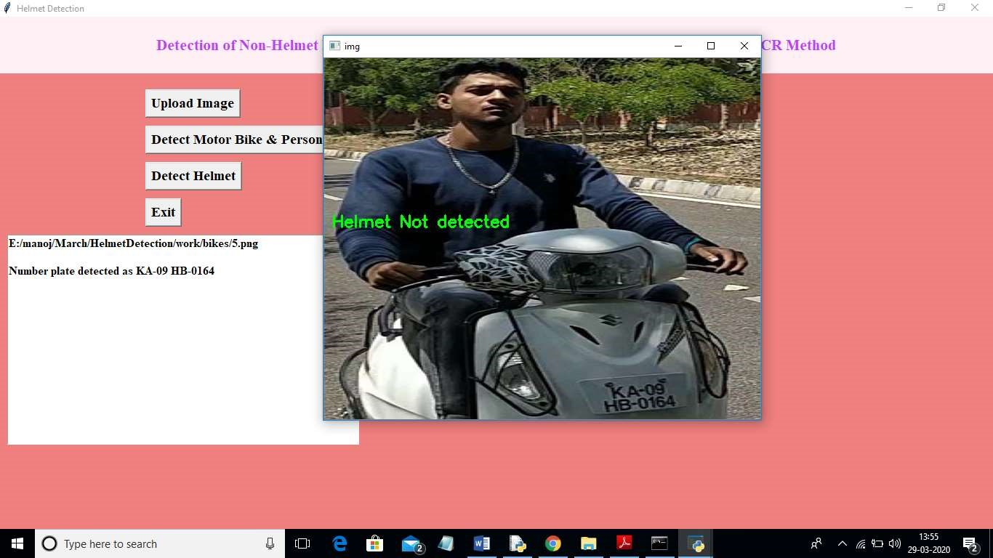
In above screen application detected that person is not wearing helmet and its extracted number from vehicle and display in beside text area.
FIG 7.4: FINAL OUTPUT

8.CONCLUSION

A Non-Helmet Rider Detection system is developed where a video file is taken as input. If the motorcycle rider in the video footage is not wearing helmet while riding the motorcycle, then the license plate number of that motorcycle is extracted and displayed. Object detection principle with YOLO architecture is used for motorcycle, person, helmet and license plate detection. OCR is used for license plate number extraction if rider is not wearing helmet. Not only the characters are extracted, but also the frame from which it is also extracted so that it can be used for other purposes. All the objectives of the project is achieved satisfactorily.
The main objective of the study was to develop an algorithm for automatic detection of LP for non-helmeted motorcyclists. A single convolutional neural network was implemented to accomplish the task. The detected license plate can be used in the ANPR technology to recognize the LP characters, which can be further used in analyzing the information. A centroid tracking method was also proposed to reduce the number of false positives generated by the helmeted bikers when their helmet is out of video frame. The proposed system was able to detect the license plate of those motorcyclists who wears a hood or cap. The overall LP detection rate for non-helmeted motorcyclists was 98.52%. The system relies on the LP located at the rear position since Thai motorcyclist does not have LP on the front area.

8.1.FUTURE SCOPE

Our project can be linked with the traffic cameras and with some modifications it can be used to detect helmets in the real time system. Further more we can merge the algorithm of automated license plate detection and make a system which generates challans for those who don’t wear helmets. It seems like you are interested in the future scope of number plate detection without helmet. As of my last knowledge update in January 2022, technologies related to computer vision and image processing, such as number plate detection, continue to evolve rapidly. The future scope for such technologies can be shaped by several factors. Here are some potential future directions. Integration with Autonomous Vehicles: As autonomous vehicles become more prevalent, there could be an increased demand for robust and reliable number plate detection systems. These systems could be crucial for identifying and tracking vehicles on the road. Enhanced Security and Surveillance: Improved number plate detection systems can enhance security and surveillance applications. This can be valuable in law enforcement, border control, and other areas where monitoring and identification of vehicles are essential. Machine Learning and AI Advancements: Continued advancements in machine learning and artificial intelligence could lead to more accurate and efficient number plate detection algorithms. This may involve the use of deep learning techniques and neural networks. Cloud Integration: The integration of number plate detection systems with cloud computing can lead to more scalable and accessible solutions. Cloud-based systems could enable real-time data analysis and sharing across different platforms.

9.BIBILOGRAPHY

- J.Chiverton, “Helmet Presence Classification with Motorcycle Detection And
Tracking”,IET Intelligent Transport Systems,Vol. 6, Issue 3, pp. 259–269, March 2012.
- Rattapoom Waranusast, Nannaphat Bundon, Vasan Timtong and Chainarong Tangnoi, “Machine Vision techniques for Motorcycle Safety Helmet Detection”, 28th International Conference on Image and Vision Computing New Zealand, pp 35-40, IVCNZ 2013.
- Romuere Silva, Kelson Aires, Thiago Santos, Kalyf Abdala, Rodrigo Veras, Andr´e Soares, “Automatic Detection Of Motorcyclists without Helmet”, 2013 XXXIX Latin America Computing Conference (CLEI).IEEE,2013.
- Romuere Silva, “Helmet Detection on Motorcyclists Using Image Descriptors and Classifiers”, 27th SIBGRAPI Conference on Graphics, Patterns and Images.IEEE, 2014.
- Thepnimit Marayatr, Pinit Kumhom, “Motorcyclist‟s Helmet Wearing Detection
Using Image Processing”, Advanced Materials Research Vol 931- 932,pp. 588592,May-2014.
- Amir Mukhtar, Tong Boon Tang, “Vision Based Motorcycle Detection using HOG features”, IEEE International Conference on Signal and Image Processing Applications (ICSIPA).IEEE, 2015.
- Abu H. M. Rubaiyat, Tanjin T. Toma, Masoumeh Kalantari-Khandani, “Automatic Detection of Helmet Uses for Construction Safety”, IEEE/WIC/ACM International Conference on Web Intelligence Workshops(WIW).IEEE, 2016.
- XINHUA JIANG “A Study of Low-resolution Safety Helmet Image Recognition
Combining Statistical Features with Artificial Neural Network”.ISSN: 1473-804x
9. Kunal Dahiya, Dinesh Singh, C. Krishna Mohan, “Automatic Detection of Bikeriders without Helmet using Surveillance Videos in Real-time”, International joint conference on neural network (IJCNN). IEEE, 2016.
10. Maharsh Desai, Shubham Khandelwal, Lokneesh Singh, Prof. Shilpa Gite, “Automatic Helmet Detection on Public Roads”, International Journal of Engineering Trends and Technology (IJETT), Volume 35 Number 5- May 2016, ISSN: 2231-5381.

